# **Microsoft Certified Azure Administrator Associate AZ:104**

**Implement Azure IaaS**

Course-end Project 1

**Step 1: Create virtual networks in the aforementioned region**

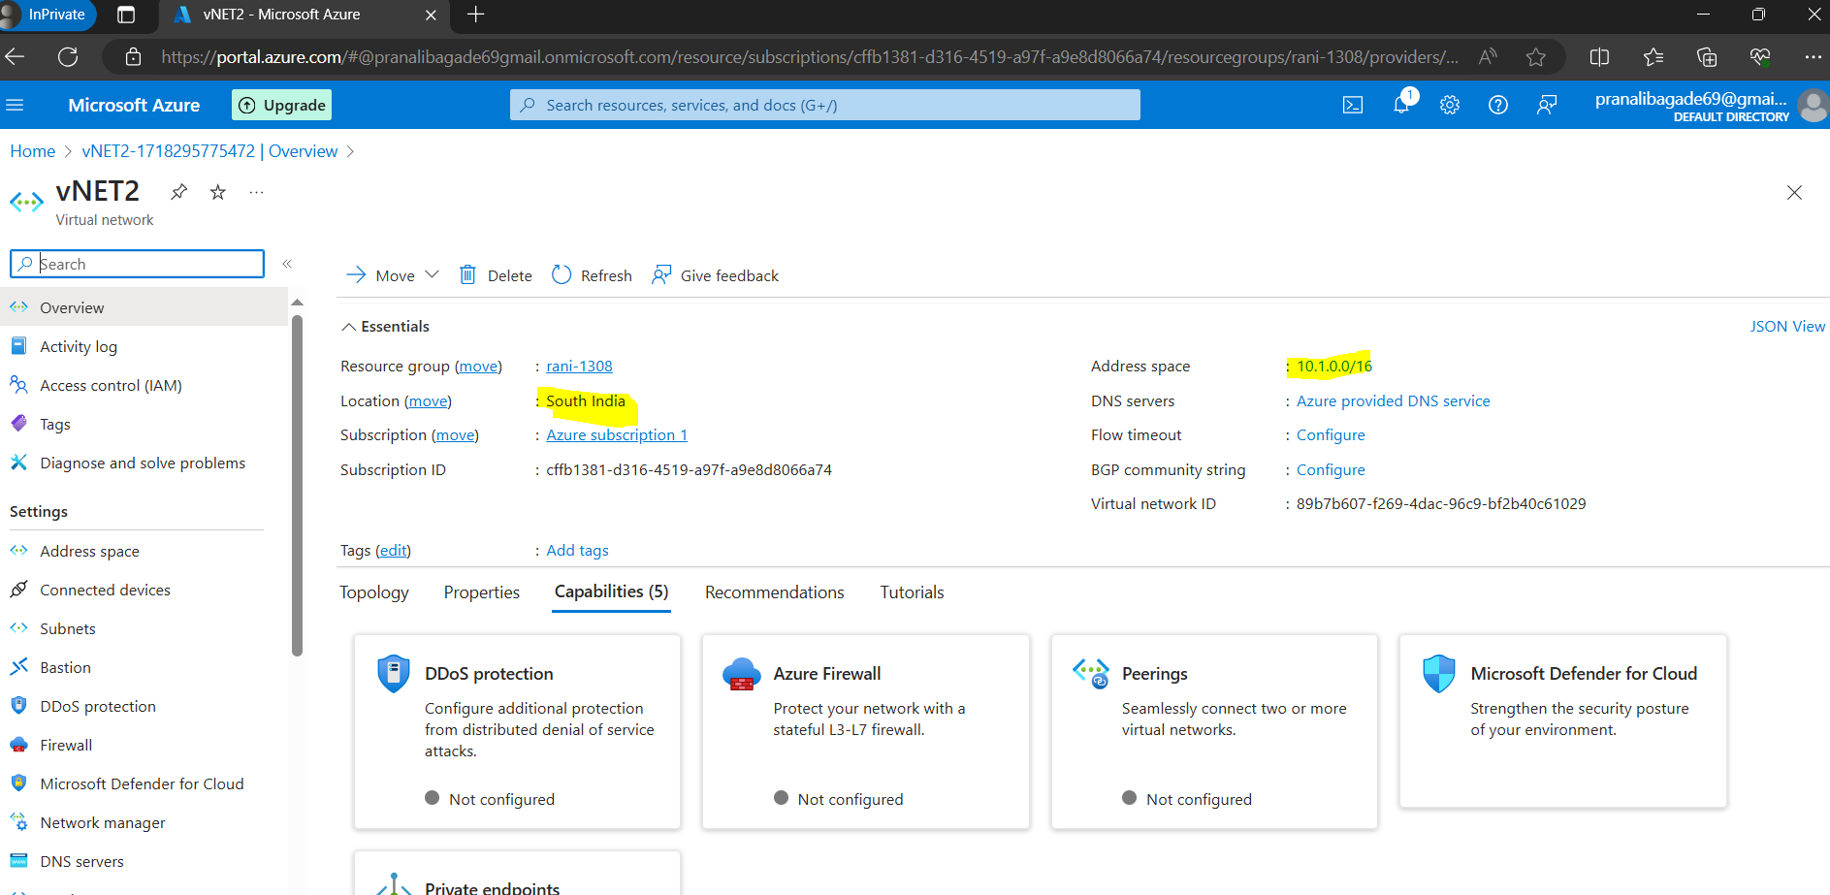

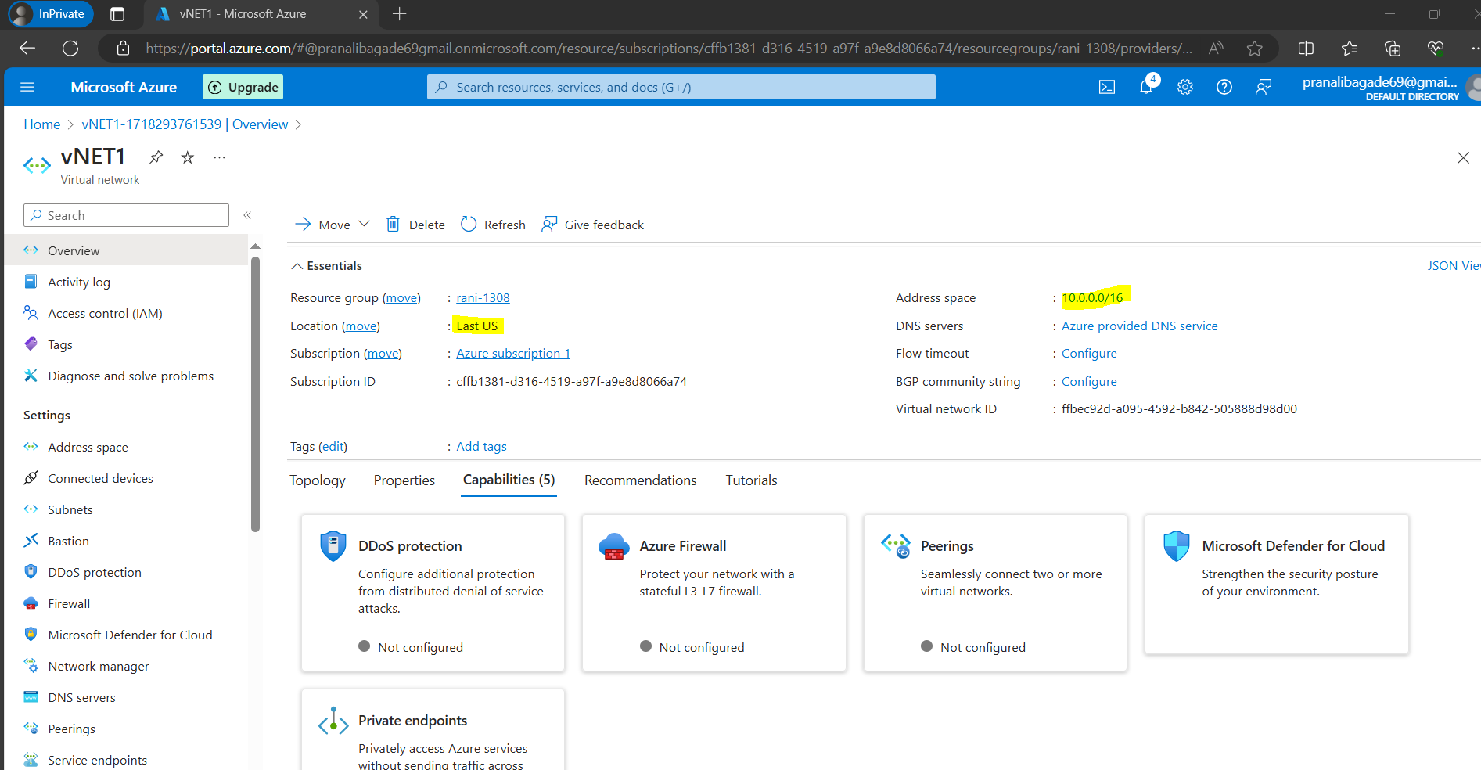

**2. Create test virtual machines in both the virtual networks**

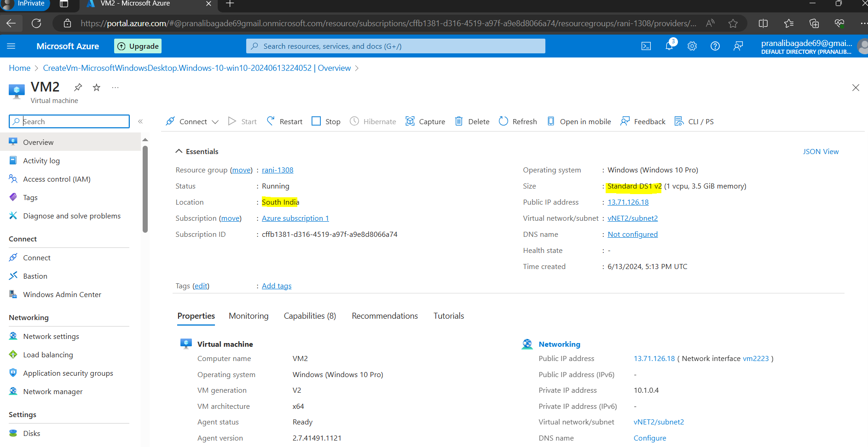

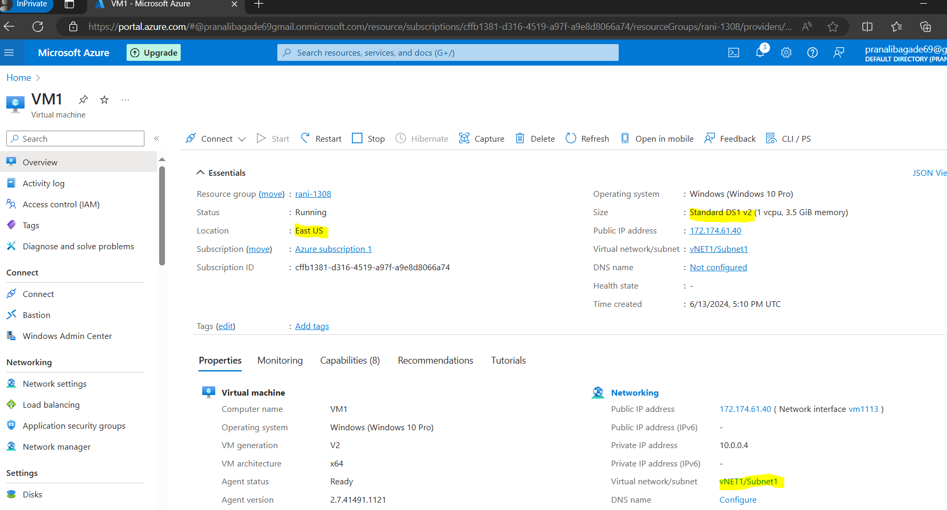

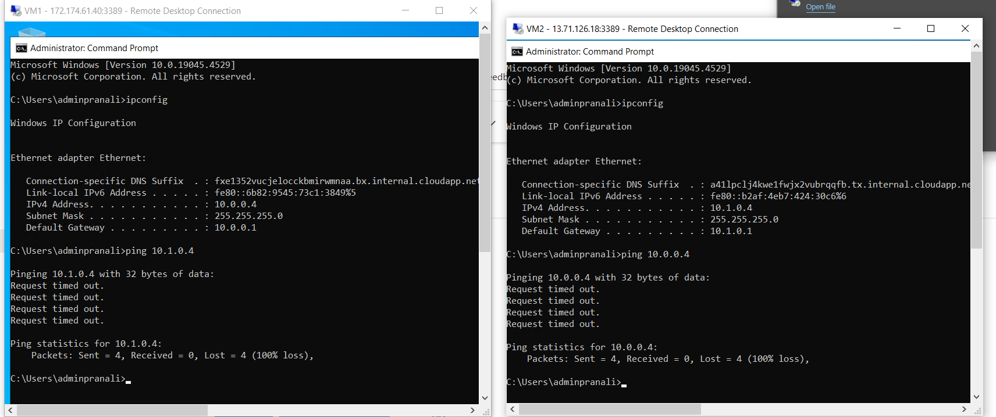**3. Establish the connectivity between both the networks via VNet peering**

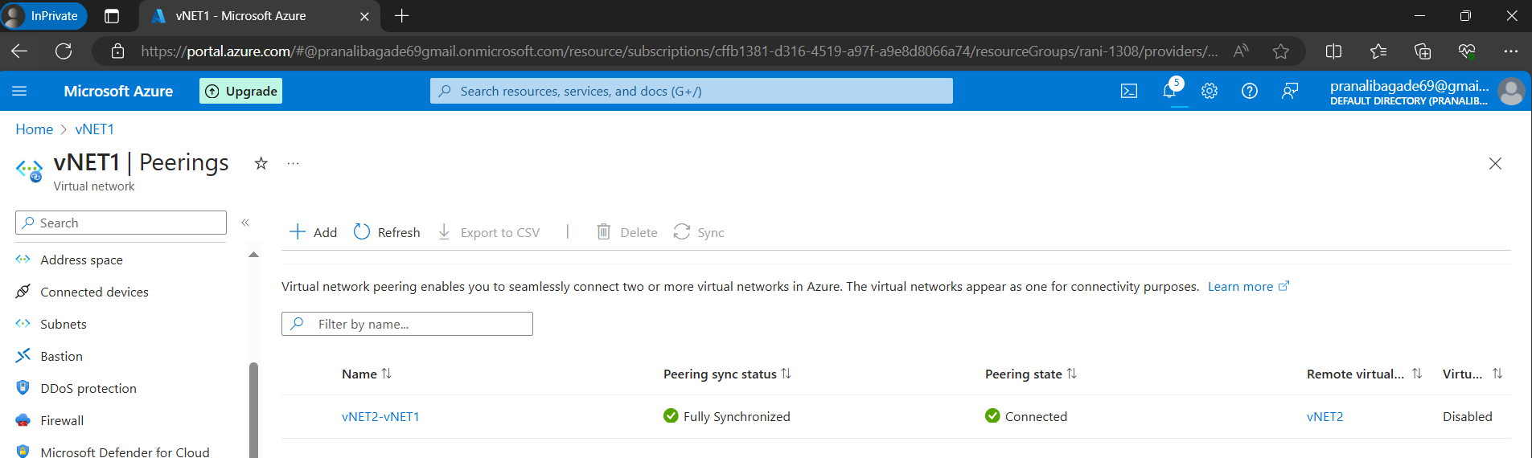

**4. Ensure connectivity is established properly**

